**Smart Mugs - Drinking Habit Tracker**

ECE 445 Project Proposal

Team#56: Srishti Modgil, Siqi Lu, Hani Al Majed

Professor: Olga Mironenko

TA: Selva Subramaniam

Spring 2023

1. **Introduction**
   1. **Problem**

There is a problem with the inconvenience associated with maintaining the perfect temperature of beverages. Drinks can cool down quickly, making them no longer enjoyable; or tea can be too hot to drink, hurting people’s throats and tongues. The need to reheat a drink can also be time consuming and inconvenient especially with a packed schedule. There is also a problem with waste. Disposable cups and reheating drinks can contribute to waste and negatively impact our environment.

During our research, we found a smart mug called Embur Mug which can detect the temperature of the beverage and keeps it to a desired temperature. However, this mug is way too expensive for people to purchase with a price of 130 dollars. Is it possible for us to reduce the expense and improve the functionality of this smart mug at the same time? This is the main problem we are going to solve in this project.

* 1. **Solution**

We propose the creation of a smart mug. Our design will improve the Embur Mug functionally and financially. The desired mug will be equipped with a temperature control system that will automatically regulate the temperature of its contents to keep the drink at a desirable level. The mug will also have an app interface that will allow users to easily set up their preferred temperature of specific drinks, track their liquid intake and how fast they consume their liquid. The smart mug has the ability to keep drinks at the perfect drinking temperature and will eliminate the need for reheating. The smart mug will also track the amount of liquid in your cup at the moment. We will use a sensor to detect the weight of the liquid and display the number of ounces on your app. The smart mug not only improves the hot beverage drinking experience but also helps promote sustainable habits.

* 1. **High-level Requirements**
* The product will identify the temperature and the weight of the input beverage within seconds and send this information to the microcontroller.
* The phone application will be able to receive the data from the microcontroller and send information back to the microcontroller in order to complete a specific task such as re-heating, sending high temperature warning and refilling notification. We also expect the application to store daily data and generate drinking habit reports.
* The device is washable and chargable without damaging the electronic systems. The expense of this device should be 20% lower than a smart mug in the market.  
  1. **Visual Aid**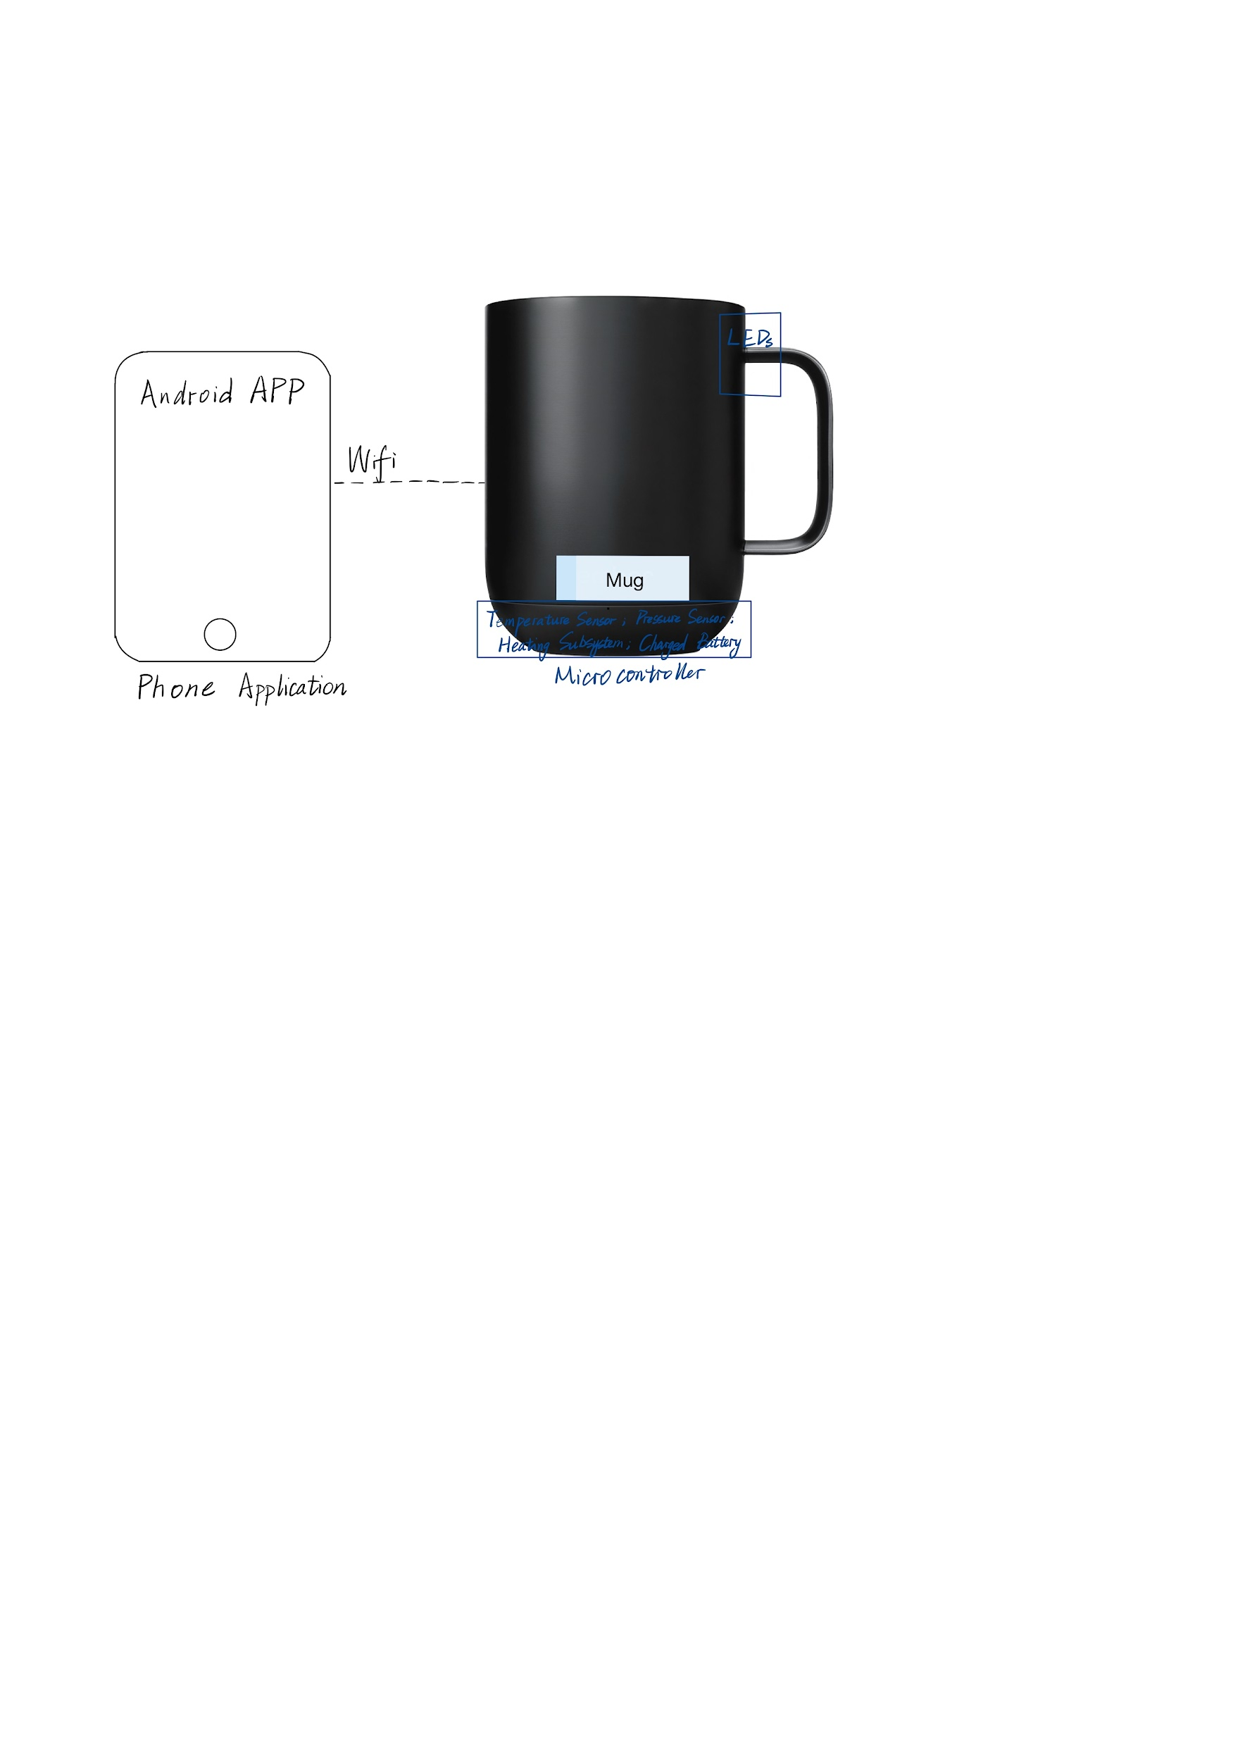

1. **Design**
   1. **Block Diagram**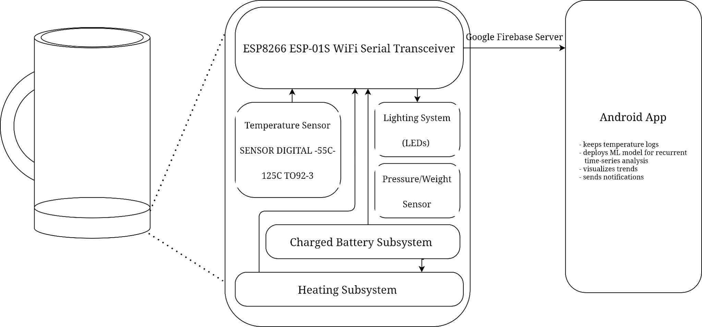
   2. **Subsystem Overview**

Subsystem 1 Sensor Subsystem

This subsystem contains two sensors, temperature sensor and pressure sensor. The temperature sensor is used to detect the temperature of the input beverage and the pressure sensor is used to track the pressure change inside of the device. These two sensors then give the microcontroller the data required for other subsystems.

For the temperature sensor, we planned to use the industry standard temperature sensor by Maxim Integrated (DS18B20+T&R).

Requirement:

* The subsystem will be capable of tracking the temperature and weight of the liquid with high accuracy in a short amount of time.
* The subsystem will be able to send the microcontroller the data required by other subsystems.

Subsystem 2 Microcontroller with Wifi transceiver

* ESP8266 SoC board: standard Arduino generic microcontroller with a serial Wifi transceiver to regulate power, control the other subsystems, and send logs to a server that visualizes/analyzes data and handles app notifications.
* <https://www.amazon.com/DIYmall-ESP8266-ESP-01S-Serial-Transceiver/dp/B00O34AGSU>

Subsystem 3 Lighting System (only LEDs)

* LED indicating the temperature scale of the beverage (on the mug)
* Send notification to phones if too hot or too cold. (user setting on the apps)
* Flashing light when too much liquid in the cup
* Flashing light when too hot
* Maybe include a dimming feature to control the brightness of the light
* Will include safety features to prevent electrical hazards, such as automatic shut-off in the event of overheating or a malfunction in the light source.

Subsystems 4 Heating System

* Maintaining the beverage to a desired temperature/healthy temperature.
* Can adjust the temperature of the cup in your app
* Different settings will be available for different types of drinks
* Warning settings for too hot or too cold
* Will include temperature control circuitry to regulate the temperature of the liquid. Maybe a temperature sensor and a microcontroller that adjusts the power supplied to the heating element based on the temperature of the liquid.
* The heating system should include safety features to prevent electrical hazards, such as automatic shut-off in the event of overheating or a malfunction in the heating element.

Subsystem 5 Charged Battery Subsystem

This subsystem utilizes a universal Qi wireless charging trasmitter and receiver modules by Adafruit (<https://www.adafruit.com/product/2162> & <https://www.adafruit.com/product/1901>) to perform inductive charging of a Samsung 25R 18650 2500mAh 20A Battery. These modules can be configured to track battery level.

Requirement:

The Qi receiver module must draw 5 V of output voltage and deliver 500 mA of current to recharge the proposed Li-Ion battery.

Subsystem 6 Android Application Subsystem

An android app will be developed to process and display the data acquired from the ESP8266 microcontroller and Wifi transiever SoC board.

Requirement:

A minimum requirement for the functionality of this subsystem is to handle notifications, process time-series data fetched from the configured Google Firebase server, and visualize drinking habits.

* 1. **Tolerance Analysis**

1. Heating Element: Tolerance analysis would consider the range of temperature variations that the heating element can produce and how it affects the overall heating of the liquid in the mug.
2. Liquid Weight Sensor: Tolerance analysis would consider the range of weights that the sensor can measure accurately and how variations in the sensor's readings affect the accuracy of the mug's weight measurement.
3. Power Source: Tolerance analysis would consider the range of voltages and currents that the power source can provide, and how these variations affect the performance of the heating element and weight sensor.
4. Mug Material: Tolerance analysis would consider the effects of variations in the mug's material properties, such as its thermal conductivity and thermal expansion, on the overall performance of the smart mug.
5. **Ethics and Safety**

The IEEE Code of Ethics expected us, as future engineers, to commit ourselves to the highest ethical and professional conduct and agree:

1. *To uphold the highest standards of integrity, responsible behavior, and ethical conduct in professional activities*
   1. to hold paramount the safety, health, and welfare of the public, to strive to comply with ethical design and sustainable development practices, to protect the privacy of others, and to disclose promptly factors that might endanger the public or the environment;
   2. to improve the understanding by individuals and society of the capabilities and societal implications of conventional and emerging technologies, including intelligent systems;
   3. to avoid real or perceived conflicts of interest whenever possible, and to disclose them to affected parties when they do exist;
   4. to avoid unlawful conduct in professional activities, and to reject bribery in all its forms;
   5. to seek, accept, and offer honest criticism of technical work, to acknowledge and correct errors, to be honest and realistic in stating claims or estimates based on available data, and to credit properly the contributions of others;
   6. to maintain and improve our technical competence and to undertake technological tasks for others only if qualified by training or experience, or after full disclosure of pertinent limitations;
2. *To treat all persons fairly and with respect, to not engage in harassment or discrimination, and to avoid injuring others.*
   1. to treat all persons fairly and with respect, and to not engage in discrimination based on characteristics such as race, religion, gender, disability, age, national origin, sexual orientation, gender identity, or gender expression;
   2. to not engage in harassment of any kind, including sexual harassment or bullying behavior;
   3. to avoid injuring others, their property, reputation, or employment by false or malicious actions, rumors or any other verbal or physical abuses;
3. *To strive to ensure this code is upheld by colleagues and co-workers.*
   1. to support colleagues and co-workers in following this code of ethics, to strive to ensure the code is upheld, and to not retaliate against individuals reporting a violation.

We are committed to have personal standards of conduct consistent with the IEEE and ACM Code of Ethics, but also beyond it.

**Resources**

1. Ember Mug: <https://ember.com/products/ember-mug-2?variant=30843977826389&a=1&a=1&a=1&a=1&gclid=CjwKCAiAleOeBhBdEiwAfgmXf_lS8_LxedMdbgWazgfJ_4wzhcjqQ7uzlqpE1mobNka8gJXf2WwC5xoCeGAQAvD_BwE>
2. Industry standard temperature sensor by Maxim Integrated: <https://www.digikey.com/en/products/detail/analog-devices-inc.-maxim-integrated/DS18B20%2BT%26R/3478852?utm_adgroup=Sensors%2C%20Transducers&utm_source=google&utm_medium=cpc&utm_campaign=Shopping_Supplier_Maxim%20Integrated_8022_Co-op&utm_term=&utm_content=Sensors%2C%20Transducers&gclid=CjwKCAiAleOeBhBdEiwAfgmXf-hIaZj1YjASEiDZOg5dMMVtSrDlfEeoC1fjx_hQg3LjqtbzHDXz3xoCAXYQAvD_BwE>
3. Samsung 25R 18650 2500mAh 20A Battery - INR18650-25R

<https://www.18650batterystore.com/products/samsung-25r-18650?utm_campaign=859501437&utm_source=g_c&utm_medium=cpc&utm_content=201043132925&utm_term=_&adgroupid=43081474946&gclid=CjwKCAiA0JKfBhBIEiwAPhZXD4K0buQB4llCTCdtCz7RvFwBTh2EiDKCG829OV8GOinTmFSQxTqOxBoCbw0QAvD_BwE>

1. IEEE Code of Ethics:

<https://www.ieee.org/about/corporate/governance/p7-8.html>

1. <https://www.amazon.com/Aexit-Constant-Temperature-Thermostat-62a01bc958a5f7f6a5ffa32d53a6b472/dp/B0838KJXFW>
2. <https://global.kyocera.com/prdct/ecd/peltier/>